

Draw It or Lose It

CS 230 Project Three Software Design Document
Version 1.0

Table of Contents

CS 230 Project Software Design Template 1
Table of Contents 2
Document Revision History 2
Executive Summary 3
Requirements 3
Design Constraints 3
System Architecture View 3
Domain Model 3
Evaluation 4
Recommendations 5

Document Revision History

Version | Date | Author | Comments
1.0 | 02/21/26 | Duc Huy Cao | Project Three submission: completed Recommendations section and aligned content to template.

Executive Summary

The Gaming Room is expanding its existing game, Draw It or Lose It, beyond a single platform. The goal is to deliver a consistent multiplayer experience across web and mobile clients while maintaining performance, scalability, and security. This software design document summarizes the core requirements, evaluates hosting options, and recommends a Linux-based server platform with containerized deployment to support reliable growth.

Requirements

Key functional and nonfunctional requirements for Draw It or Lose It include:
• Support multiple teams and players in concurrent game sessions.
• Enforce uniqueness of game and team identifiers to avoid duplicate instances.
• Provide low-latency client interaction (timers, drawing events, score updates).
• Enable cross-platform access through a networked, service-based architecture.
• Scale horizontally as user demand grows, with high availability targets.
• Protect user data and game state in transit and at rest.

Design Constraints

The game is delivered in a web-based, distributed environment, which imposes constraints that influence design and deployment:
• Concurrency and consistency: multiple players interact with shared game state simultaneously, so server-side logic must be thread-safe and avoid shared mutable state without coordination.
• Scalability: the server should be largely stateless to enable horizontal scaling; durable state should be stored in a database and/or distributed cache.
• Network variability: clients may experience latency, jitter, and outages, so the design must tolerate retries, timeouts, and partial connectivity while preserving gameplay fairness.
• Cross-platform clients: browsers and mobile devices require standard protocols (HTTPS, REST, WebSockets) and backward-compatible APIs.
• Security and compliance: authentication, authorization, encryption in transit, secrets management, and audit logging must be built into the platform and deployment pipeline.
• Operational portability: the solution must run consistently across environments (dev/test/prod), favoring containers and infrastructure-as-code.

System Architecture View

Draw It or Lose It follows a three-tier web architecture. Clients (web browsers and mobile apps) communicate with a server-side game service over HTTPS using REST APIs for session management and WebSockets (or server-sent events) for near-real-time gameplay updates. The service persists durable data (users, game sessions, scores) in a relational database and uses an in-memory cache for fast session lookups and rate limiting. This separation enables independent scaling of the application tier and data tier and supports deployment behind a load balancer.

Domain Model

The UML class diagram models the core domain objects and their relationships. GameService is a singleton that provides a single authoritative entry point for creating and retrieving games, ensuring unique identifiers and preventing duplicate game names. Game represents a game instance and aggregates Team objects; each Team aggregates Player objects. These associations (Game 1..* Teams; Team 1..* Players) reflect the real-world structure of the game. Encapsulation is used to protect state through controlled accessors, and abstraction is achieved by exposing high-level operations (e.g., addGame, getGame, getGameByName) rather than exposing internal collections. The singleton pattern centralizes lifecycle and state management for games on the server.
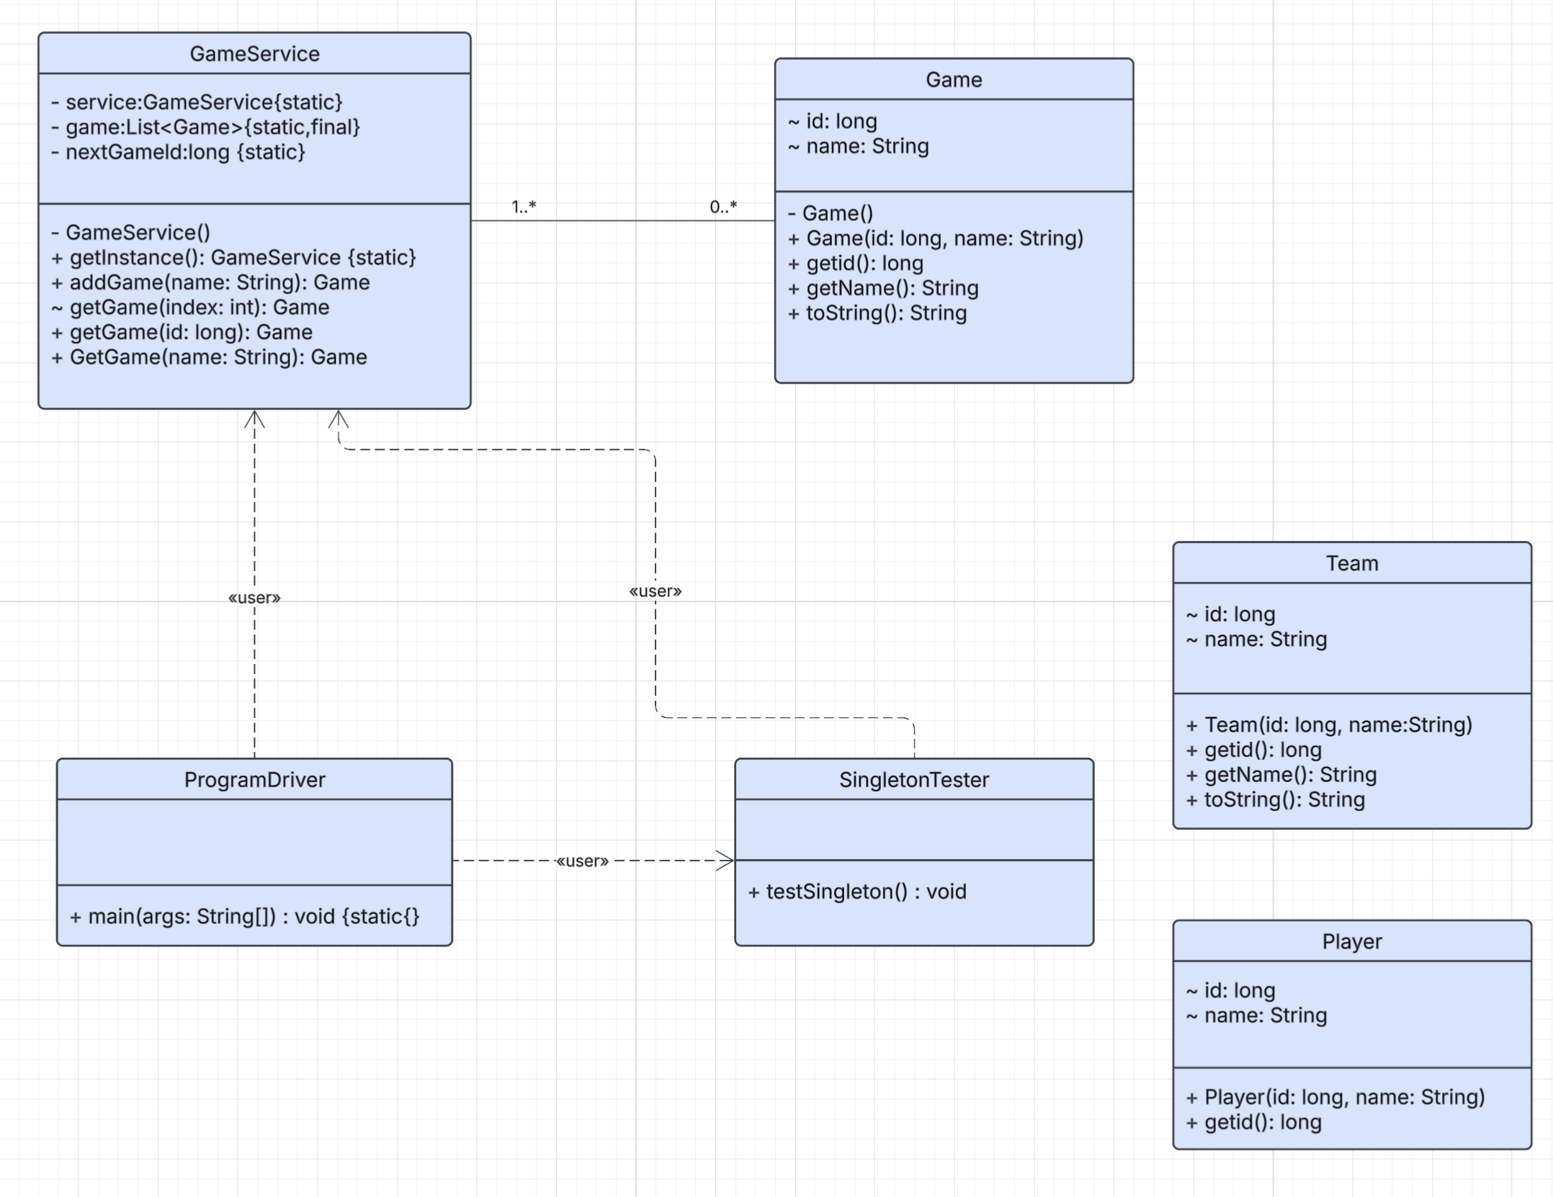
Figure 1. UML class diagram for the Gaming Room code base.

Evaluation
The table below compares server-side and client-side development considerations across Mac, Linux, Windows, and mobile devices for the Draw It or Lose It game.

Development Requirements | Mac | Linux | Windows | Mobile Devices
Server Side | macOS can host Java web services for development or small deployments, but it is not commonly used as a production server platform. Hardware cost is higher, and enterprise hosting options are limited compared to Linux. It is best suited for local development and testing rather than scalable production hosting. | Linux is the de facto standard for cloud hosting. It offers strong performance, low licensing cost, and first-class support for containers and orchestration (Docker/Kubernetes). Most managed services, observability stacks, and automation tooling target Linux, making it the strongest choice for a scalable game server. | Windows Server can host Java/.NET services and integrates well in Microsoft-centric environments. However, it often has higher licensing and operational overhead for container-first, Linux-native ecosystems. It is viable when organizational tooling or dependencies require Windows. | Mobile devices are not appropriate for hosting the server side of a web-based multiplayer game. They are resource-constrained, have unreliable connectivity and power states, and cannot provide the availability and security controls expected for a server workload.
Client Side | Supporting macOS clients is straightforward via modern browsers. Development considerations focus on testing across Safari/Chromium, packaging differences, and ensuring consistent UI performance. Costs are primarily QA time and access to Apple hardware for testing. | Linux clients are typically supported through browsers (Chromium/Firefox) with many desktop distributions. The main consideration is browser compatibility and varying hardware drivers. Cost is moderate and is primarily testing across common browser versions. | Windows has the largest desktop install base, so browser support is essential. Development focuses on compatibility with Edge/Chrome/Firefox and diverse hardware. Cost is driven by QA coverage and supporting different Windows versions. | Mobile support requires responsive UI, touch input handling, performance optimization, and careful network handling on cellular connections. Development cost is higher due to platform-specific testing (iOS/Android), app store packaging (if native), and device fragmentation.
Development Tools | Java/JDK; IntelliJ IDEA or VS Code; Maven/Gradle; Git; Docker Desktop; Safari/Chrome dev tools. | Java/JDK; IntelliJ/VS Code; Maven/Gradle; Git; Docker/Podman; kubectl/helm; CI/CD tooling. | Java/JDK; IntelliJ/VS Code; Maven/Gradle; Git; Docker Desktop (WSL2); Windows/Azure tools as needed. | Android Studio and Xcode; or Flutter/React Native; Postman; device testing and mobile CI pipelines.

Recommendations
The following recommendations focus on the server platform and architecture needed to scale Draw It or Lose It reliably while protecting user data across platforms.
- Operating Platform: Recommend Linux (Ubuntu Server LTS) as the primary operating (server) platform for the Draw It or Lose It backend, deployed on a major cloud provider or managed Kubernetes. Ubuntu LTS provides a predictable patch cadence, long-term security updates, and broad compatibility with Java, containers, and observability tooling. Linux is the industry default for cloud hosting, enabling cost-effective horizontal scaling behind a load balancer and automation with infrastructure-as-code.
- Operating System Architectures: Standardize production on 64-bit x86-64 Linux instances, with ARM64 as an optional tier where cost/performance is favorable. A 64-bit architecture provides a larger virtual address space for JVM heaps and the OS page cache, reducing memory pressure as concurrency increases. Linux's monolithic kernel provides mature scheduling, networking, and filesystem stacks; namespaces and cgroups enable container-level isolation and resource control. Container images keep the runtime consistent across dev/test/prod and across hardware architectures.
- Storage Management: Use a layered storage model: (1) a durable relational database such as PostgreSQL on persistent block storage for users, sessions, and scores; (2) Redis as an in-memory cache for session lookups, rate limiting, and ephemeral coordination; and (3) object storage for logs, static assets, and backups. On Linux, format database volumes with a journaling filesystem (ext4 or XFS) and mount them as dedicated data partitions to isolate I/O. Enable automated snapshots/backups, point-in-time recovery, and replication to meet availability and disaster-recovery requirements.
- Memory Management: Linux manages memory with per-process virtual address spaces, paging, and a page cache that accelerates disk reads; under pressure it reclaims cache pages and, if enabled, may swap. For a latency-sensitive game service, run with bounded memory using cgroups/container limits and tune the JVM heap and garbage collection (for example, G1GC) to avoid long pauses. Monitor RSS, heap usage, GC pause time, and OOM events; alert on trends that indicate leaks or runaway caching. Prefer minimizing swap and use health checks so unhealthy instances are recycled quickly.
- Distributed Systems and Networks: Use a distributed client-server model: clients connect over HTTPS/REST for authentication, session setup, and state queries, and use WebSockets (or SSE) for real-time drawing events and score updates. Place the service behind a TLS-terminating load balancer with health checks; run multiple stateless application instances and store shared state in PostgreSQL/Redis so instances can scale horizontally. Design for unreliable networks with timeouts, retries with exponential backoff, idempotent APIs, and reconnection logic for WebSockets. Handle dependencies and outages using circuit breakers, graceful degradation, and multi-zone deployment to reduce single points of failure.
- Security: Apply defense-in-depth to protect user data on and between platforms: enforce TLS 1.2+ in transit, strong authentication and authorization (token-based sessions), and rate limiting/WAF protections at the edge. Encrypt sensitive data at rest (database volumes and backups) and manage keys and secrets with a secrets manager; grant least-privilege IAM roles to services. Harden the Linux OS by keeping packages patched, disabling unnecessary services, using SSH keys and MFA, and enforcing host firewall rules; use AppArmor/SELinux profiles and container image scanning to reduce attack surface. Centralize audit logs and security monitoring to support detection and incident response.

